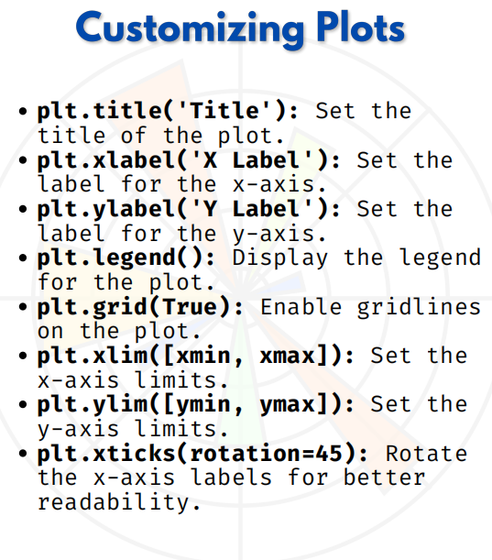

CUSTOMIZING PLOTS

1. plt.title('Title') → Add Title
import matplotlib.pyplot as plt
x = [1, 2, 3, 4, 5]
y = [2, 4, 6, 8, 10]
plt.plot(x, y)
plt.title("Simple Line Plot") # Title added
plt.show()
Adds a title to the plot.

2. plt.xlabel('X Label') → X-axis Label
plt.plot(x, y)
plt.xlabel("X Axis Values") # Label for x-axis
plt.ylabel("Y Axis Values")
plt.show()
Describes what the x-axis represents.

3. plt.ylabel('Y Label') → Y-axis Label
plt.plot(x, y)
plt.xlabel("Time (s)")
plt.ylabel("Speed (m/s)") # Label for y-axis
plt.show()
Adds meaning to the y-axis.

4. plt.legend() → Show Legend
plt.plot(x, y, label="Line A")
plt.plot(x, [i**2 for i in x], label="Line B")
plt.legend() # Display legend
plt.show()
Differentiates multiple plots with names.

5. plt.grid(True) → Show Gridlines
plt.plot(x, y)
plt.grid(True) # Adds grid for better readability
plt.show()
Helps to align values with axes.

6. plt.xlim([xmin, xmax]) → Set X-axis Limit
plt.plot(x, y)
plt.xlim([0, 6]) # Restrict x-axis from 0 to 6
plt.ylim([0, 12]) # Restrict y-axis from 0 to 12
plt.show()
Focuses on a specific data range.

7. plt.xticks(rotation=45) → Rotate Labels
days = ["Monday", "Tuesday", "Wednesday", "Thursday", "Friday"]
sales = [100, 120, 90, 140, 160]
plt.bar(days, sales)
plt.xticks(rotation=45) # Rotate x labels
plt.title("Sales Over Days")
plt.show()
Makes long labels easier to read.

